NATIONAL MANAGEMENT COLLEGE
National Management Wing

CASE STUDY
“Streamlining the Process of Maintenance of Federal Government Residential Accommodations in Islamabad, Through Development and Implementation of a Systematic & Judicious Financial Management Strategy in CDA”

NATIONAL MANAGEMENT COURSE -117

NATIONAL MANAGEMENT COLLEGE, LAHORE

By
FAHAD Haroon Aziz
(PA&AS)

A paper submitted to the faculty of the National Management College, Lahore in partial fulfillment of the requirement of the National Management Course-117.
The paper is the end product of my own efforts, research and writing and has not, in whole or in part, been submitted elsewhere for assessment and its contents are not plagiarized. The paper reflects my own views and is not necessarily endorsed by the faculty or the college.
Word Count: 7,202

Signature …………….
Date: 28th January, 2023
Paper Supervised by: MR. NADEEM MAHBUB

Contents
1. Context / Introduction 1
2. Statement of Intent 2
3. The Scene Setter 2
4. Background & Overview of Government Housing 3
5. The Case Study and its Analysis 5
5.1 Pre-Launch Challenges 6
5.1.1 Convincing the Senior Management of CDA 6
5.1.2 Resistance Management & Convincing Field Formations 8
5.1.3 Team Building 8
5.1.4 Devising a framework of the Policy 9
5.1.5 SOP’s for Repair & Maintenance of Government Residences 10
5.2 Post Launch Challenges 12
5.2.1 Pressure of the Peers and Influential Senior Officers 12
5.2.2 Maintaining Uniformity of policy and Resistance 13
6. Impact of the New Policy 13
7. Conclusion 14
8. Lessons Learnt 15
9. Recommendations and Way Forward 17
10. Bibliography 19
11. Annexures 20

1. Context / Introduction
Housing, a basic human right, is one of the most important urban issues in developing countries and at the same time one of the single largest expenditure item in the budgets of most households. There are millions of people working for the government all over Pakistan. Coping with the increasing pressure for new government housing and maintaining the quality of existing housing is a great challenge for the government.
In the capital of the country Islamabad, Capital Development Authority (CDA) is primarily responsible to oversee the maintenance of federal government housing. Capital Development Authority was created under an ordinance, issued on June 27, 1960, essentially to oversee the planning, development and maintenance of Islamabad. Later on its fold and control was also extended to the municipal issues of Islamabad. The senior management of CDA consists of a Chairman and five board members who are appointed by the Federal cabinet. These members head the Finance, Engineering, Planning and development, Estate management and Administration wings.
As the Authority grew and matured along with the capital, several extra responsibilities were n added to its fold, one of which was the maintenance of Federal Government buildings and residential accommodations for government employees in Islamabad. There are 17,496 federal government owned residential accommodations in Islamabad on estate office pool. These are allotted to the government employee’s category wise according to their scale and seniority. Majority of these residences were built quite a while back in 1970’s and 1980’s and due to passage of time and poor maintenance, most of them are not in good livable conditions. Capital Development Authority is tasked to carry out the repair/maintenance of majority of these accommodations. Each year the federal government allocates and releases maintenance grant to CDA for repair/maintenance of government houses. The maintenance work is a recurring activity which takes place round the year and there is always a huge difference in the demand for repair/maintenance of government housed and the actual funds released by the federal government each year.
It is therefore, extremely important that the available funds are utilized in a systematic manner to ensure that the maintenance work is carried out more effectively and efficiently. Traditionally there existed no policy in CDA for evaluating and allocating the amount of funds for the said repair/maintenance and the process was being carried out haphazardly. For a proper and judicious allocation of the limited funds and to ensure repair/maintenance of maximum number of government houses, the Finance Wing of CDA under the command of Member Finance devised and implemented a more streamlined policy and SoP’s for the purpose.

2. Statement of Intent
The intent of this narration is to elucidate that how a well-planned policy can play a key role in the maintenance and upkeep of public sector housing. The conventional process being followed was arbitrary, disorganized and failed to address the issue to the satisfaction of clients. Contrarily, the policy devised and implemented provided certain benchmarks and reduced individual discretion and favours leading to rationalization of the system.
This study aims to explore the diverse aspects and dynamics of undertaking and implementation of the initiative for streamlining the maintenance process of thousands of federal government residences in Islamabad. It attempts to share all the issues, predicaments and experiences encountered by Member Finance CDA and his team in carrying out this worthwhile initiative. This is the story of a public servant who saw difficulties and challenges not as stumbling blocks but as stepping stones. It shares the experiences and lessons learnt during planning and implementation of this initiative as it may inform public policy, and assist civil servants, while undertaking similar initiatives in comparable contexts in other public sector organizations in Pakistan.

3. The Scene Setter
It was a hot, humid and rainy afternoon of August 2017. The skies of Islamabad were dark and covered with dense clouds with erratic thunder bolts lighting up the atmosphere off and on. Mr. Zimaar, Member Finance/FA CDA was sitting in his office at CDA Head Quarters, Islamabad. He had just returned from a long informal meeting with the honourable Wafaqi Mohtasib, where he had been apprised of the numerous complaints by federal government employees about the inordinate long delays in the repair/maintenance of their allotted residences. Most of these related to junior scale officials who did not have access to senior management at CDA. In the past few months several government servants had approached him through his friends and colleagues to get funds for repair of their allotted houses and expressed similar nature grievances. In the preceding weeks a meeting had also been also held in Capital administration and Development Division (CAAD) on a related issue. All these events underscored the fact that something was off. Mr. Zimaar was quite perturbed with the pattern and realized that the existing system of maintenance was neither fair and nor serving the needs of the clients.
He returned to his office solemn and determined to find a better functioning solution. While sitting in his chair looking out on the well maintained green lawn through his window Mr. Zimaar picked up the intercom and asked his staff officer to schedule a meeting with his core team and directors of maintenance wing CDA at 9:00 am tomorrow. The next morning in a three and a half hour marathon meeting he discussed the issue threadbare with his colleagues while taking key note points to help him make a plan accordingly. During the course of interaction the seriousness and extent of the assignment was revealed. CDA was looking after nearly 15,000 government residences and the annual funds released by the government were hugely short to maintain all of them each year. On top of that there appeared no rational criteria for the distribution of limited available funds. More often than not the influential and well-connected officers managed to get the funds allocated for the upkeep of their allotted residences time and again and while millions and millions of Rupees were being spent for them, there were others who could not get any share at all form the grant. Comprehending that the existing system was not working efficiently, Member Finance decided to devise a new policy for better management. He now wanted to undertake a dispassionate analysis to determine how he could achieve his desired objectives. He had realized that the task would require resolve and steadfastness as by changing the status quo he would be stepping on many a toes. However he could foresee that it was also a good opportunity to facilitate a large number of hitherto neglected government servants. So without wasting much time he tasked his team to start working on the assignment to charter, develop and implement a more rational and judicious policy to streamline the process of maintenance of government owned residential accommodations in Islamabad.

4. Background & Overview of Government Housing
Housing and healthy living environment are basic human need having far reaching social implications. Housing is a multi-faceted term usually defined as a shelter for the human beings; however it can be defined in numerous ways depending upon the perspective. As per Oxford Dictionary, “house” is a building for human abode and “housing” is for dwelling houses mutually. United Nation, however, has different take on the definition of housing. Under its view; housing is not only a shelter but also a mean to create communities.
The rapid urbanization and massive migration towards urban areas has resulted in exponential growth of cities, which led to increased demand for housing against the limited supply causing land scarcity and augmented property values. This has compelled the people to live in dwellings, which were either too small or in very bad condition.
The effect of this urbanization has been far greater in developing countries like Pakistan, where the successive governments have failed to come up with a well-planned and effective housing policy for the general public as well as government servants. Today Pakistan is experiencing an unprecedented urban housing crisis. The World Bank predicts that Pakistan faces a housing shortage of 10 million units.
There is a general opinion in Pakistan that, though housing is basic need of citizens, the government is not effectively managing the issues related to housing sector. The extent of housing shortfall is on high side in comparison to growth of population. The conditions under which the housing is produced and consumed in developing countries like Pakistan are characterised by a series of imperfections and there is considerable rigidly on supply side arising from the bottlenecks in the availability of complementary inputs like construction materials and weak municipal services. The main obstacle which hampered the formulation and just implementation of housing policy were the extreme shortage of funds available, constantly increasing gap between supply and demand curve and increasingly high maintenance costs of housing. A good living environment, security and comfort are necessary for the housing of government employees.
However owing to the above-mentioned factors and due to improper maintenance the government housing conditions in Pakistan, both in terms of quantity and quality, remains generally poor and keeps worsening with the passage of time. The majority of these houses are old and dilapidated but located on probably the most valuable land in the country. A few indicators to judge the housing conditions in government sector include congestion or crowding, provision of civic amenities, structural quality including timely repairs and cultural adequacy.
Institute of Asset Management emphasizes that maintenance management is the art and science of making the right decisions and optimizing the management of physical . In a debate on how to address housing woes, scholars have argued that the housing agenda should focus not only on the production of new housing units but also to concentrate on ways to sustain the existing stock.
The repair and maintenance of dwellings is one of the most important and most challenging elements of the public housing service. It has been subject to widespread criticism for high costs, inefficiency and slowness in carrying out repairs. However, improving the quality of repairs and maintenance is often a complex task since this service is generally provided by a variety of administrative, professional and technical staff. The severe paucity of resources and the lack of a coherent planned maintenance strategy is one of the most serious problems in maintenance of government housing in Pakistan.

5. The Case Study and its Analysis
According to the Estate Office record, the federal government owns approximately 28,454 houses across Pakistan, out of which the majority (61.4%) are located in Islamabad. There is a huge gap between demand and supply of government houses in Islamabad and the existing houses were mostly in poor condition partly due to lack of resources and partly due to unwise maintenance practices. Member Finance, CDA had made up his mind to overhaul and revamp the existing practice of repair / maintenance of government owned residences by CDA. His ultimate objective was to come up with a plan to institute and implement a streamlined and efficient process of maintenance of government owned residential accommodations in Islamabad. He had worked hard to convey it loud and clear to senior management at CDA that he intended to bring a justifiable and sustainable solution for the ills of existing procedures. However the solution was not coming easily. Any change even small is generally resisted. Nielsen (2008) quoted that organizational change is complex and even little changes are not easy to undertake. The organizational culture, unfavorable resource situation and multiple other unknown obstacles were standing in the way of Mr. Zimaar. Keeping in view the expected bottlenecks, the Member Finance, CDA chalked out a multi-dimensional and comprehensive plan that consisted of the challenges likely to be faced and a strategy to cope with each challenge. The challenges were divided into two categories i.e. pre-launch and post-launch.

5.1 Pre-Launch Challenges

5.1.1 Convincing the Senior Management of CDA
The first and foremost challenge was selling the reform initiative to the Chairman and senior management of CDA. The Member Finance was cognizant of the fact that if he could convince the Chairman and senior management about the need and benefits of streamlining the process of maintenance of federal government residential accommodations in Islamabad, through development and implementation of a systematic and judicious financial management strategy, the acceptance and implementation of reform policy would become easier.
Therefore he sought audience with the chairman in the early hours of Monday which was granted. On the given day and time the Member Finance called upon the Chairman who cordially welcomed him and ordered two cups of hand tossed coffee. They started discussion on the development affairs of the Authority and Member Finance apprised the Chairman on the various steps he had taken so far to streamline the financial matters of the CDA. The Chairman also asked the Member Finance to strengthen the system of internal control to avoid any wasteful expenditure. The Member Finance assured the Chairman that he would conduct a meaningful review of the system of internal controls and report back and took this as an opportunity to raise the issue of poor management of government accommodations due to lack of any policy and internal controls. He went on to explain that there were very limited funds available every year for the purpose and through a transparent and judicious financial management policy the maintenance activity can be done in a much better way. The Chairman seemed quite receptive to the idea, and while sipping his coffee nodded, but before both of them could expand the conversation any further the staff officer walked in and informed the Chairman that his meeting with Chairman Senate scheduled for 11 am has been moved early and he needed to leave for it immediately. Realizing that a meaningful conversation could not proceed any further as the Chairman CDA’s presence was required in the august chamber of Chairman Senate on priority, Member Finance sought leave and come back to his office. However the Chairman assured him that they would discuss the idea again soon.
Member Finance’s next one on one meeting with the Chairman took place a few days later, where he again elucidated in detail the issues faced by government servants and gave examples of a few cases where many a millions have been spent on houses of influential officers year after year and yet others were scrambling form pillar to post to get even the basic repairs done. He highlighted the need and importance of a proper and judicious policy for allocation of funds and introduction of limit on yearly spending on a particular category of house to ensure repair/maintenance of maximum number of government houses. He then requested the Chairman to grant approval for initiating the process. The Chairman who had given a patient hearing to the Member finance all along said that while he agreed with the proposal in principle, yet it would be better if other board members were also taken into confidence before arriving at a decision.
The Member Finance felt a bit sullen and discontented but he did not lose heart, as he genuinely believed that he would be able to help a large number of government servants by pushing through the initiative. He decided to use the time as an opportunity to have a larger ownership of his reform proposal. He thanked the Chairman for his support and requested to hold the subject meeting early. The Chairman was agreeable and picked up the intercom and asking his staff officer to call an informal meeting of board members on coming Monday at 10:00 am. Member Finance decided to use the next few days as an opportunity to call upon the senior officers beforehand and apprise them about the reform idea, who after much coaxing promised their support. The next Monday during the meeting all the participants supported the proposal, except Member Engineering Wing who was not in favour and saw no issue with the existing mechanism. Member Finance then also informed them about his long and protracted meeting with the honourable Wafaqi Mohtasib, where he had made a promise on behalf of CDA to evoke a fair policy for better management of the repair/maintenance of government allotted residences. For the final push he also linked the matter with incurring the displeasure of the office of honourable Wafaqi Mohtasib if no step was taken to streamline the matter. This ploy worked. The Member engineering was still reluctant but seeing that majority of participants were in favour the Chairman intervened and gave a go ahead to the proposal and asked the member finance to put up a comprehensive policy for consideration. Finally the unrelenting efforts had borne fruit and the endorsement of beginning the process of streamlining the maintenance of Federal Government Residential Accommodations in Islamabad was obtained.

5.1.2 Resistance Management & Convincing Field Formations
The second challenge was to decrease and manage resistance among the stakeholders in CDA against the reform initiative. The Member Finance decided to hold meetings with the heads of various engineering directorates in CDA, involved in the process. Change is neither easy nor comfortable. Not surprisingly, Members Finance initial meet ups were met with misgiving and suspicion. Recognizing the hesitancy he skillfully steered the meetings in a way as to seek guidance from the concerned officers in designing the policy roadmap, while concomitantly assuaging their fears and increasing their understanding about the purpose and benefits of the reform initiative. The meetings played an important role in marketing of his idea and turned out to be a key step in decreasing the resistance and bringing majority of stakeholders on board even if apprehensively.
Any change proposal often finds itself in conflict with the existing pathway and its followers. This has been witnessed across Pakistan and CDA was no stranger to this struggle. Member Finance was well aware that introducing change and reform in a process that had been going on for many a years will mean stepping on many toes, will be an ongoing challenge and he will have to work incessantly to break through the resistance and succeed. He also decided to take the field formations into confidence explaining to them that the planned policy making would be a consultative exercise which will eventually improve the working and the performance of field formations. He hoped to bring everyone on one page, develop a cooperative relationship and then set a direction for betterment of everyone. Although the maintenance managers were still wary of the proposed change, this strategy to some extent reduced the customary rigidity and attitudes while allaying the distress of the unknown towards the proposed change.

5.1.3 Team Building
Mr. Zimaar had always been a team player. He realized the importance and value of building a reliable and efficient team to execute the plan to further his mission. Therefore, he went about the task of scrutinizing the available human resource of the Department, identified a few young go getters and computer literate officials at CDA headquarters and got tem posted under his command. To further augment his team, Mr. Zimaar used his sway and connections at his parent office and brought in some of the best officials to be part of his team. He leveraged his personal relationship with the honorable AGP, who has remained his direct boss some time ago, to get a competent and trustworthy BS 19 officer, Mr. Raza to be posted on deputation as deputy financial advisor in CDA. to act as his second in command. Member Finance wanted to introduce systematic decision making on all the issues of important nature in Finance wing of CDA. He wanted to devote more of his time to larger policy issues and for that he delegated some functions and powers to Mr. Raza with specific authority and responsibility. The first task Member Finance assigned to him was to computerize all data of funds allocation of government housing repair and maintenance and maintain an open line of communication with the concerned engineering directorate of CDA, so that informed decisions could be made while drafting the new policy.

5.1.4 Devising a framework of the Policy
The maintenance managers in CDA faced problems in conducting maintenance operation due to unclear plan and unsystematic approach towards funds management. In order to implement an effective and judicious building maintenance and keeping in view the very limited availability of funds for the purpose, selecting the most appropriate maintenance strategy was very crucial. Therefore the last pre-launch challenge pertained to devising standard operating procedures (SOPs) and mechanisms for planning, executing and operationalizing a new and streamlined process of house maintenance with the help of a judicious financial management strategy. It was not an easy task because hitherto no such attempt had been made in CDA and Member Finance and his team had to start from scratch.
The thing working to his advantage was the preemptive head start he had already taken in parallel while soliciting approval of the Chairman and negotiating through other pre-launch challenges. He had already tasked the finance wing team to start collecting and collating data about the number of government houses maintained by CDA. Which houses had been maintained in the last three years and what amount of funds were spent on them and also to carry out a survey and list those residential accommodation where no repair and maintenance has been carried out since last 5 to 10 years. In his heart he was convinced that if he could devise and implement a logical and functional policy in the case there was a good chance that the arrangement would continue be a success and become an integral part of housing maintenance system in CDA. The very next morning he called his team to formally initiate the process. The strategy of parallel work had paid off and the basic data was in place. All that was needed was to analyze the available data and frame a SOP whereby despite the limitation of financial resources maximum number and maximum categories of government houses could be repaired in the annual plan. Now the Member Finance was feeling enthusiastic and hopeful as all ingredients for devising and launching an effective and efficient policy were in place.

5.1.5 SOP’s for Repair & Maintenance of Government Residences
CDA is an autonomous body which generates its own funds through land disposal policies, fees and taxes. However it cannot spend its self-generated funds on maintenance of government buildings. It maintains Government buildings and houses on behalf of and out of funds provided by Federal Government every year. The grant is released under the head ‘Other government Buildings’ and is meant for repair and maintenance of government houses numbering around 15000 and some other major buildings including Pak Secretariat, Ex-USAID building, Jinnah Convention Center (JCC) and Faisal Mosque etc.
There is a maintenance Directorate in CDA which is responsible for carrying out the necessary repair / maintenance works of the government houses. The government employees move an application to the concerned maintenance division requesting for the carrying out the required maintenance work. The maintenance staff prepares a detailed estimate of the work to be carried out and after approval from Member (Engineering) submit the case file to Finance Wing for allocation of funds out of the maintenance grant provided by the federal government.
Class & Categories of Government Accommodation in Islamabad
As per CDA record there were 14,903 government houses in the federal capital on the pool of Estate Office catering for residential accommodation of government employees which are being maintained by CDA. These government houses provide residential accommodation facility to all eligible employees in BPS 1 to 22. The Government Employees Accommodation Categories and Classes for Federal Government Servants (FGS) are detailed as under:
Basic Pay Scale of FGS | Class of Accommodation | Category of Accommodation
BPS-01 To BPS-04 | A | V – VI
BPS-05 To BPS-06 | B | V
BPS-07 To BPS-10 | C | V
BPS-11 To BPS-15 | D | IV
BPS-16 To BPS-17 | E | III
BPS-18 | F | III
BPS-19 | G | II
BPS-20 | H | I
BPS-21 To BPS-22 | I | I

The allotment of A to I class of accommodation is made in accordance with the pay scale of the Federal Government Servants as per their entitlement. The amount released by the federal government under the head was by no means sufficient to carry out the repair/maintenance activities of such huge number of government houses and building.
Scrutiny of cases being submitted to Finance Wing revealed that the Maintenance Directorates had piled up a huge number of ongoing and completed works of last 2-3 years, even beyond the allocated funds. Analysis of record also showed that budget estimates prepared for different houses of the same categories varied a lot. In some cases the estimates were on extremely higher sides, which was not justified as the funds were limited and overspending on certain individual houses leaves many other houses unmaintained. A comprehensive policy was, therefore, need of the time to warrant that the allotted funds are utilized efficiently and fairly in a systematic manner.
The Policy for Distribution of Funds for Maintenance of Government Houses
To stream line the issue and ensure transparent and judicious allocation of funds for maintenance of houses, following policy was introduced by Member Finance in CDA:

- Instead of individual officers approving the repair estimates, a committee may be constituted by the Engineering Wing to scrutinize and recommend the estimates of repair/ maintenance of the Government houses before submission to the competent authority for final approval.
- Budget allocation ceiling (for both civil & electrical works) for various Category of houses is proposed as under:
Sr. No | Category | Maximum allocation upto (Rs.)
1. | A, B &C | 300,000
2. | D & E | 400,000
3. | F & G | 600,000
4. | H & I | 800,000
Note: Only in exceptional circumstances and on concrete justification and scrutiny, the Chairman CDA may allow increase in the above specified ceilings
- All the estimates shall be prepared by the maintenance Directorates for repair works as per above ceiling so as to ensure that maximum number houses/government officials are accommodated.
- All old cases of repair work already approved may also be re-examined and rationalized on the basis of the above budgetary ceiling so that maximum number of houses may be accommodated within the budgetary provision for the financial year.
- It should be ensured that only repair and maintenance works may be included in the estimates and all new construction work should be excluded from all the new and old estimates prepared in maintenance Divisions.
- For a fair and systematic allocation of funds of Maintenance grant following points/instructions may also be included in SOP for approval:
- The demand for allocation of funds may be provided to Finance wing, CDA with the ratio of 75:25 by the DG (Services) and D.G (E&M) respectively.
- No token allocation will be demanded by the formations for new works so as to avoid creation of unnecessary future liabilities.
- Splitting of work is also strictly prohibited.
- No file shall be submitted by hand to Finance Wing and all files must be submitted through official channels and proper diary/dispatch.

5.2 Post Launch Challenges

5.2.1 Pressure of the Peers and Influential Senior Officers
Facing pressure from the influential senior officers of the federal government whose houses were being repaired and upgraded regularly over the years in a discretionary manner was a great challenge. Every other day Member Finance would receive a call from higher ups and senior bureaucracy to accommodate them by allocating additional funds over and beyond the policy limits. Being a member of the civil service fraternity, it was quite problematic for Mr. Zimaar to say no to senior officers who wielded enormous clout and weightage in the corridors of power. This was compounded by peer pressure where colleagues of Member Finance expected special favours. Each day after the introduction of new policy one or two friends, colleagues or senior officers would approach him to flout the newly started policy and give them extra funds for the repair of their allotted houses. The Engineers very conveniently shifted the entire burden on finance wing by telling the applicants that they were willing to help but it was Member Finance who had stopped them from executing extra work on their houses. Hence the entire weight of the newly introduced policy and its implementation was shifted to the shoulders of Member Finance, CDA.

5.2.2 Maintaining Uniformity of policy and Resistance
Observing the uniform standard in repair and maintenance works to avoid inequality/favoritism among the allottees was a huge challenge for Member Finance. The contactors and maintenance directorates kept on creating hurdles in implementation. The biggest factor which tested and waivered his resolve at times was the social and cultural burden of expectations to help his seniors, friends and service batch mates by granting special favours. At times some of his friends even expressed annoyance that what the use of is having a colleague and friend who can easily help them but is refusing to do so in the garb of some so called policy. There were times when Member finance was caught in a social and moral dilemma and questioned the rationale of implementing the new maintenance policy, when it was losing him goodwill among friends, peers and senior colleagues. Burdened with all the pressure, at times he desperately wanted to oblige them. But he also knew that one favour will lead to another and then so on and it will practically invalidate the newly implemented policy at its nascent stage. Therefore in the face of all pressures he stood fast and made sure that the policy was followed as per its spirit. Slowly and steadily the new policy gained footing and led to a more efficient allocation of funds for repair and maintenance of government houses.

6. Impact of the New Policy
- The policy intervention led to a judicious and efficient allocation of fund for repair and maintenance of government houses.
- The gap between the demand for repair and maintenance of government accommodation and budget allocated was squeezed.
- Uniformity of financial spending was introduced within the categories and discretionary power to utilize funds on a particular residence was abolished.
- Due to capping of expenditure, the number of houses maintained by CDA considerably increased. The number of houses repaired and maintained in the next six months rose by 16% and in the subsequent financial year by 38%.
- Expenditure remained within the budgetary allocation and no overspending on repair and maintenance were made on the government houses in the financial years subsequent to the policy intervention.

7. Conclusion
The intent of narrating the case study is to present the Member Finance CDA’s moral dilemma to make a choice between sitting quiet, maintaining the status quo, relishing a passive and peaceful tenure posting, all the while facilitating his colleagues in bureaucracy and creating good will, or standing up for a change and reform initiative of instituting a new policy regime of streamlining the process, while facing hostile resistance from various entrenched groups and going against the established norms and procedures. It was a fight against forces of selective implementation, resource capture by elite and power play. It tries to explain how with patience, perseverance and tactics he skillfully managed to sustain the pressures, and was able to create an enabling environment for reform against all odds, introducing appropriate policy interventions, and establishing a more fair and streamlined regime with the primary objective of facilitating maximum number of federal government employees at all levels in getting their allotted residences maintained.
This case study records the noteworthy contribution made by a public sector professional while remaining within the rules and resources, which are often quoted as restrictive and inimical to innovation and creativity. In the ordinary course of work, whenever a public sector professional or organization in Pakistan is called upon to bring about change to optimize performance, there is a tendency to instantaneously come up with a long list of demands for additional resources. Without demanding any additional funds, equipment or human resources, Mr. Zimaar built a momentum for change and created ripples in the stagnant waters. This case study showcases the accomplishments and achievements of a civil servant who set in motion a reform policy, in a very short span of time, while remaining within existing rules and resources.
Mr. Zimaar’s conscience was deeply perturbed by the existing state of affairs where by well-connected officers in powerful offices were able to exert influence and get millions to spend on renovations and maintenance of their official residences houses again and again while others not having access to the corridors of power were waiting endlessly to get their fair share of the job. He therefore, despite all odds and advice, took lead to scribble a new and somewhat balanced chapter in the history books of CDA. By overcoming daunting challenges and complex problems posed by the situation, he was able to find a balanced and innovative path in the murky landscapes, which he hoped would guide the way for others, in times to come.

8. Lessons Learnt
It is important to identify the lessons that can be drawn from the entire saga. These lessons can be applicable to personal, institutional and to some extent societal level.
- First and foremost lesson learnt on personal level is that individual’s leadership, determination and focus is very important. Generally, public sector organizations tend to be fossilized and fixated on routine and are averse to change and innovation. It was the leadership of Mr. Zimaar, who was the lynchpin in this policy initiative, which had the potential to change the prevailing practices on the subject matter in CDA.
- More often than not, shortage or delay of funds becomes a pretext for inertia in government organizations. Although financial resources play a key role in projects, it is not always the money that makes the mare go. No additional financial resources were sought by Member Finance to devise and implement the change policy. So a very significant lesson derived was that if the will and determination is there, work can be also got done within limited resources.
- Another important lesson deduced is that it is critical to build ownership for any change. A broader consensus within the organization in support of any proposed change, howsoever small it may be, is very important for the success of policies. The Member Finance, CDA wielded no punitive powers to ensure cooperation from various directorates of the department, but his personal interaction and confidence building measures created a partially favourable environment conducive to launching the new framework.
- Policies can be delivered by a civil servant if they get a steady tenure. In the instant case, the Member Finance CDA worked uninterruptedly for full three years of his deputation period. So he had sufficient time to frame and start implementation of a new policy and nurture it through its budding phase. Had he not been there for a full term, the results would probably have been different.
- The lack of standardized policies gives discretionary powers to government servants which often then end up being misused. In majority of cases instead of instead of channelizing it in a positive a manner, they tend to use it for extending and receiving undue favorus. The introduction of standard procedures and policy almost always blocks these unfettered discretion of officials. This phenomenon was observed in CDA after the introduction of the reformed policy.
- Resistance to change is a common phenomenon prevalent at government organizations. One should never under-estimate the power of status quo and vested interests of the entrenched elements. Often, even seemingly harmless initiatives are seen by these actors as threat to their status and would try their best to thwart any attempt at change. Despite all efforts and assurances by member Finance CDA, a large number of the maintenance workers and contractors in CDA remained wary of the new policy and continually kept on resisting which created challenges during implementation. It is therefore, important that before embarking on transformative journey, the fears and apprehensions of such vested interests be effectively allayed and a narrative be created in support of new intervention, so that the forces of status quo do not disrupt the reform.
- There were other forces that did not want implementation of the streamlined solution as the existing non transparent system suited their vested interests. This included majority of the maintenance work contractors who were hand in glove with the other stakeholder departments were also reluctant due to mistrust, or fear of transparency. Member Finance in his zeal to make and implement the reform initiative failed to identify their clout and could not bring them on board for an easier implementation of new policy.
- Introducing reforms is an achievement but the real success is to devise a sustainability mechanism to ensure that the reform is implemented in an institutionalized manner and survives the test of time. In many cases successful reformative initiatives end up being dropped and disowned by successors. Therefore, it is vital for the sustainability of reform to build a set up that sustains the change even after leader who started it has departed from the scene. Regrettably in the given case Member Finance could not to take necessary steps to institutionalize the newly envisaged repair/maintenance policy in a way that it would continue in the future with the same zeal and spirit, long after his time served at CDA. Almost three years later, a small research and telephonic talks with officers of CDA revealed a state of organizational amnesia about the policy which was not being followed in its true spirit.
- A viable monitoring and evaluation system available to all stakeholders should have been put in place in parallel to the new policy to aid in decision making and continuity of the policy implementation process.
- Service delivery focus is seriously lacking in government organizations due to which there is a massive trust deficit between civil servants and the general public which is increasing every day. The maintenance service has a strong impact on customer satisfaction. Housing repair and maintenance is the service which most regularly brings allottees into contact with their local authority. Consequently, if they experience difficulties in having repairs carried out it is likely to negatively affect their perception of the overall performance of the local authority.

9. Recommendations and Way Forward
- In the interests of achieving best practice in the management of maintenance service, concerned authorities should establish a computerized system for recording all repairs requests which can track individual repair jobs, record the details of the work, record the timelines of the repair, record the costs of the repair and produce credible information for informed choices by the management.
- A system of performance monitoring is important for achieving good practices and service delivery in public sector housing management. Member Finance and his team could not devise a viable monitoring and evaluation system to aid the new policy. The paper based record keeping and decision making is an archaic system devoid of technology. Management information systems should be established in order to collate all of the information necessary for performance measurement which will aid the decision making and assist in policy implementation.
- Social, economic, and political variables influence policy decisions and outcomes in public administration. To develop, adopt, and implement policies that have the greatest benefits, senior government officials must be well familiar with the concept of institutionalization of policies and the importance of buy in of the senior leadership. .
- Whatever the change may be, once it is decided that it is to be effectively implemented, attention should be paid to institutionalizing each element of the change; otherwise, it becomes difficult to maintain the benefits resulting from the corresponding interventions. Continued change management across the board must be ensured, through nudge-based public policy tools and other behavioral techniques for keeping relationships and networks directed towards achievement of desired goals. It is also important to identify strategic level players who can exert hierarchical influence on the implementation level workers.
- The success rate of change initiatives is rather poor, not only when initiating the change, but even after the successful implementation of a well-planned change, as employees are likely to return to their old habits; thus most change efforts do not persevere. There is consensus among academics and researchers in support of the widely cited statistic that almost 70% of change initiatives fail. These high failure rates become an increasing issue not only when initiating the change, but even a long time after successful change, as employees are likely to return to their old habits, so that most change efforts do not persist . Organizations therefore need to ensure and build systems and mechanisms that their change initiatives, last long enough to attain their goals
- The streamlined policy framed by Member Finance was primarily based on concentration of resources on reactionary maintenance by responding to repairs requests from tenants. Although there will always be a demand for response maintenance, a well-developed programme of preventive maintenance is the way forward and vital to preserve the condition of the housing stock. Subject to availability of resources the necessity of planned maintenance approaches as an essential component of sustainable housing can be argued, both to extend the life of housing assets and to ensure householder health and wellbeing.
- Finally, the proper maintenance of government residential facilities all over Pakistan remains a great challenge due to mal practices and inadequate funding. Keeping in view the current and future fiscal problems it is more than likely that the funding will decrease further. So an out of the box recommendation can be made to introduce self-maintenance by the allottees. In lieu the deduction repair/maintenance allowance from their salaries should be stopped.

10. Bibliography
- Aisha Ghaus,(1990) "Magnitude of the Housing Shortage in Pakistan," in The Pakistan Development Review, Pakistan, Pakistan Institute of Development Economics, Islamabad, pp. 137-153.
- https://estate-office.gov.pk/
- Jacobs, R. L. (2002) ‘Institutionalizing organizational change through cascade training’, Journal of European Industrial Training, vol. 26, no. 2/3/4, pp. 177-182.
- Jaros, S. (2010) ‘Commitment to organizational change: A critical review’, Journal of Change Management, vol. 10, no. 1, pp. 79-108.
- Lodhi, A., & Pasha, H. A. (1991). Housing Demand in Developing Countries: A Case-study of Karachi in Pakistan. Urban Studies, 28(4), 623–634. http://www.jstor.org/stable/43195804
- Naoyuki Yoshino,(2015) "Housing Policies for Asia: A Theoretical Analysis by Use of a Demand and Supply Model," Asian Development Bank Institute.
- Nielsen, J.F., (2008), “Models of Change and the Adoption of Web Technologies: Encapsulating Participation,” Journal of Applied Behavioral Science 2008; 44; 263
- Rita Pandey, & P. S. A. Sundaram. (1997). Subsidy to Government Employees through Staff Housing. Economic and Political Weekly, 32(37), 2359–2361. http://www.jstor.org/stable/4405845.
- Royal Institution of Chartered Surveyors (RICS). 2012. RICS Public Sector Property Asset Management. Guideline 2nd Ed. Royal Institution of Chartered Surveyors (RICS): UK. 1-77.
- Shankar Lal. (2021). Issues & Challenges In Housing Schemes: A Case of Naya Pakistan Housing Scheme . Reviews of Management Sciences, 1(2), 39-51
- United Nations,(1978) "Role of housing in promoting social interaction," Department of Economic and social affairs, New York.
- UN Habitat, Metadata on SDGs Indicator 11.1.1, March 2018.
- Werkman, R. (2009) ‘Understanding failure to change: A pluralistic approach and five patterns’, Leadership & Organization Development Journal, vol. 30, no. 7, pp. 664-684.
- Wilson, K.D. & Kurz, R.S. (2008) ‘Bridging implementation and institutionalization within organizations: Proposed employment of continuous quality improvement to further dissemination’, Public Health Management Practice, vol. 14, no. 2, pp. 109–116.
- Yusof, Nor'Aini & Zainul Abidin, Nazirah & Najib, Nurul. (2013). Performance of Housing Maintenance in Public Housing. Journal of Economics and Sustainable Development. 4. 156-163.

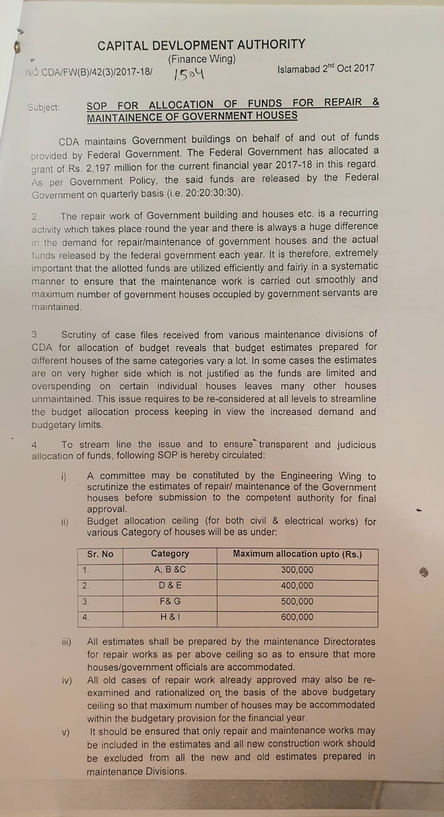
11. Annexures
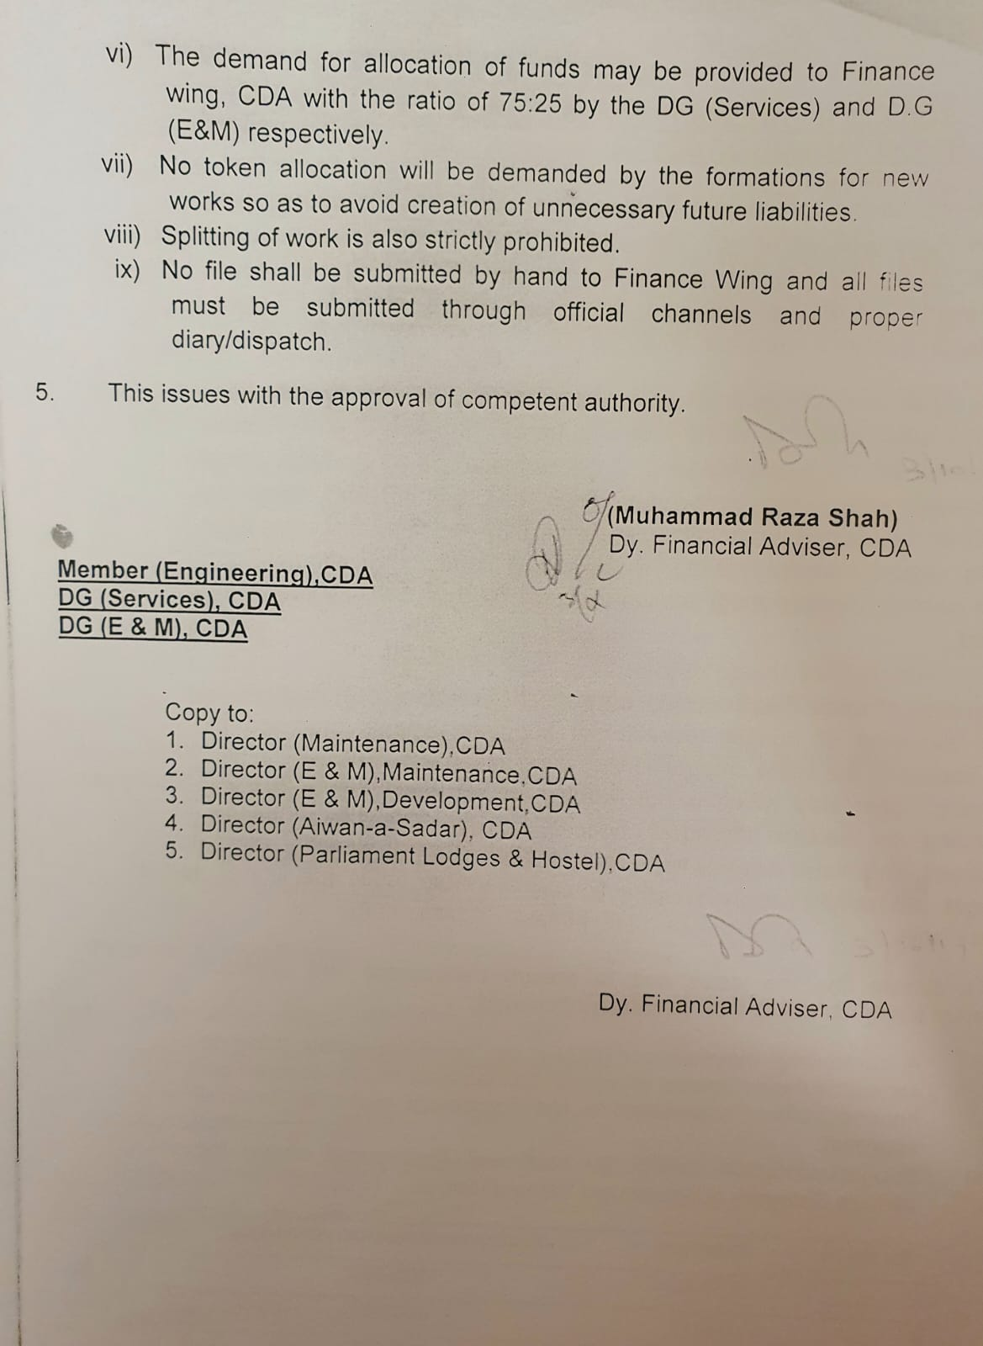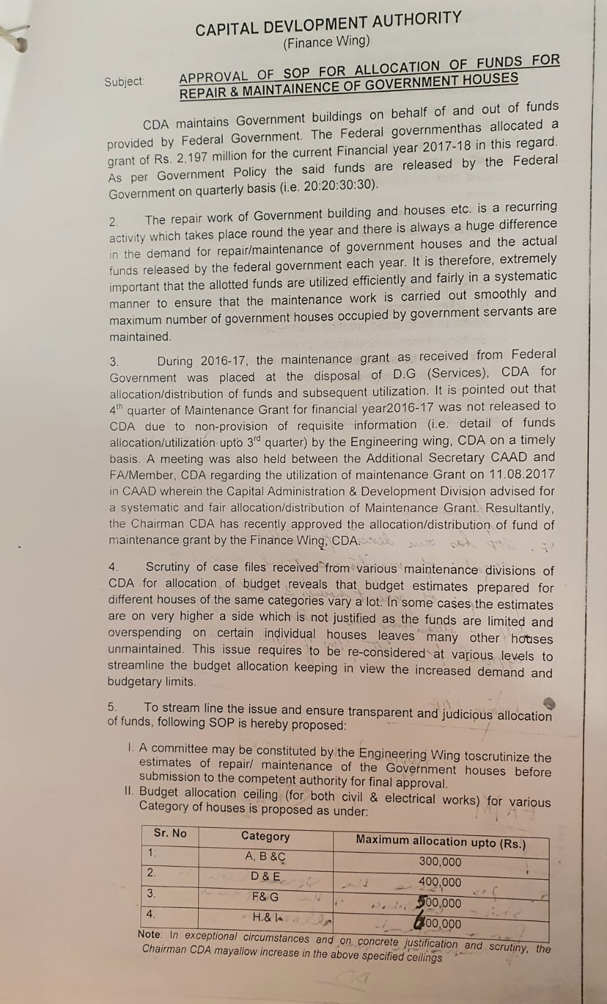
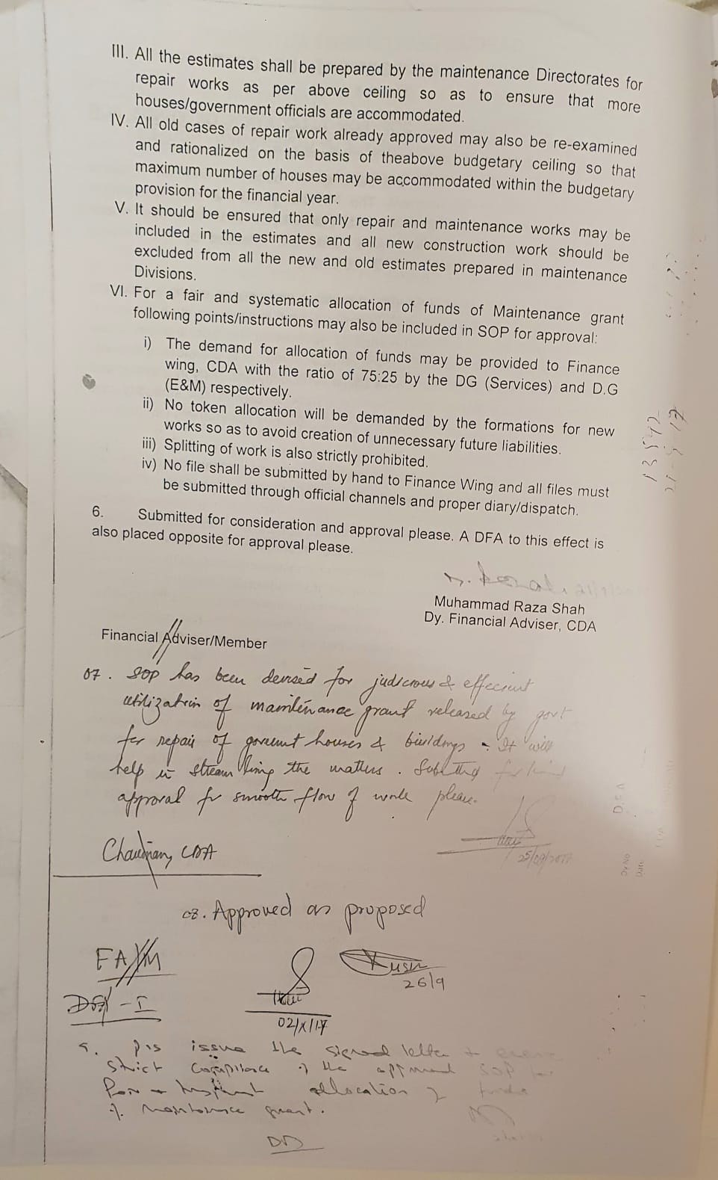

https://estate-office.gov.pk/
United Nations,(1978) "Role of housing in promoting social interaction," Department of Economic and social affairs, New York.
T. A. Naoyuki Yoshino,(2015) "Housing Policies for Asia: A Theoretical Analysis by Use of a Demand and Supply Model," Asian Development Bank Institute.
H. A. P. Aisha Ghaus, "Magnitude of the Housing Shortage in Pakistan," in The Pakistan Development Review, Pakistan, Pakistan Institute of Development Economics, Islamabad, 1990, pp. 137-153.
Lodhi, A. & Pasha, H. A. (1991). Housing Demand in Developing Countries: A Case-study of Karachi in Pakistan. Urban Studies, 28(4), 623–634. http://www.jstor.org/stable/43195804
Muhammad Rashidul Hasan and K. M. Risaduzzaman (2018), Housing for the Government Employees: A Case Study on Chittagong, International Journal of Science and Research (IJSR),Volume 7 Issue 6, www.ijsr.net
UN Habitat, Metadata on SDGs Indicator 11.1.1, March 2018.
Royal Institution of Chartered Surveyors. (2012) RICS Public Sector Property Asset Management. Guideline 2nd Ed. Royal Institution of Chartered Surveyors, UK. 1-77.
Yusof, Nor'Aini & Zainul Abidin, Nazirah & Najib, Nurul. (2013). Performance of Housing Maintenance in Public Housing. Journal of Economics and Sustainable Development. 4. 156-163.
https://estate-office.gov.pk/
Nielsen, J.F., (2008), “Models of Change and the Adoption of Web Technologies: Encapsulating Participation,” Journal of Applied Behavioral Science 2008; 44; 263
Wilson, K.D. & Kurz, R.S. (2008) ‘Bridging implementation and institutionalization within organizations: Proposed employment of continuous quality improvement to further dissemination’, Public Health Management Practice, vol. 14, no. 2, pp. 109–116.

